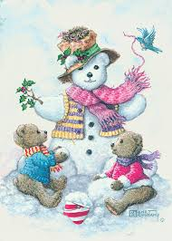
Dec. 21st – Jan. 1st No School at Centers
Dec. 25th Christmas
Jan. 1st New Year’s Day
Jan. 7th Oglala Lakota/Bennett Socials
(Kyle-11-1pm / Oglala-4-6pm)
Jan. 9th Belle Fourche Wellness Fair 9-2pm
at BFACC (Car Seat Distribution)
Jan. 11th – 14th Dakota Smiles Dental Bus in Lemmon
Jan. 11th – 14th Dakota Smiles Dental Bus in Newell
Jan. 12th Oglala Lakota/Bennett Socials
(Oglala-11-1pm / Kyle-4-6pm)

Executive Director: mbevier@badlandshs.org
Education/Disabilities Specialist: mpickle@badlandshs.org
Family Community Specialist: wdunn@badlandshs.org
Health, Nutrition, Safety Specialist: mwolf@badlandshs.org
Mental Health Specialist: rfunk@badlandshs.org

Web Site: http://badlandshs.org/

Newsletter by: Tammy McDaniel -Admin. Assistant
This institution is an equal opportunity provider and employer. 
If you wish to file a Civil Rights program complaint of discrimination, complete the USDA Program Discrimination Complaint Form, found online at http://www.ascr.usda.gov/complaint_filing_cust.html, or at any USDA office, or call (866) 632-9992 to request the form. You may also write a letter containing all of the information requested in the form. Send your completed complaint form or letter to us by mail at U.S. Department of Agriculture, Director, Office of Adjudication, 1400 Independence Avenue, S.W., Washington, D.C. 20250-9410, by fax (202) 690-7442 or email at program.intake@usda.gov.

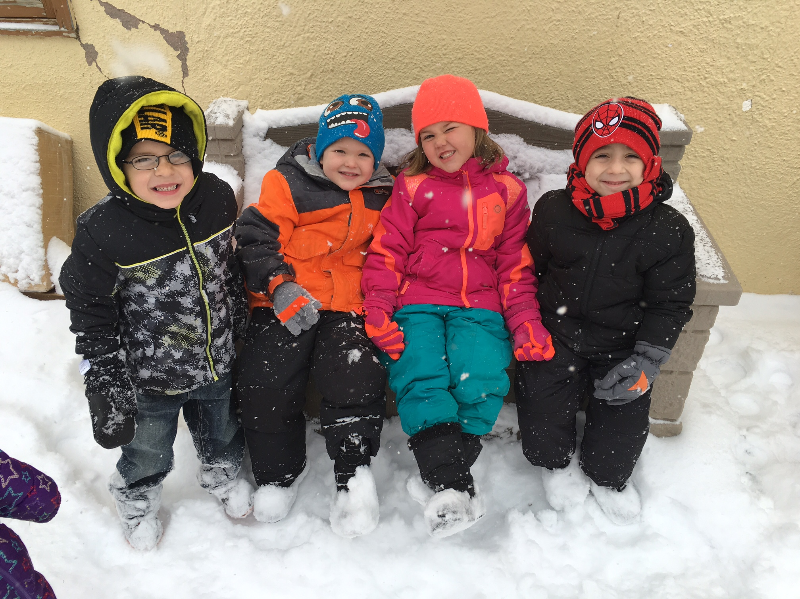
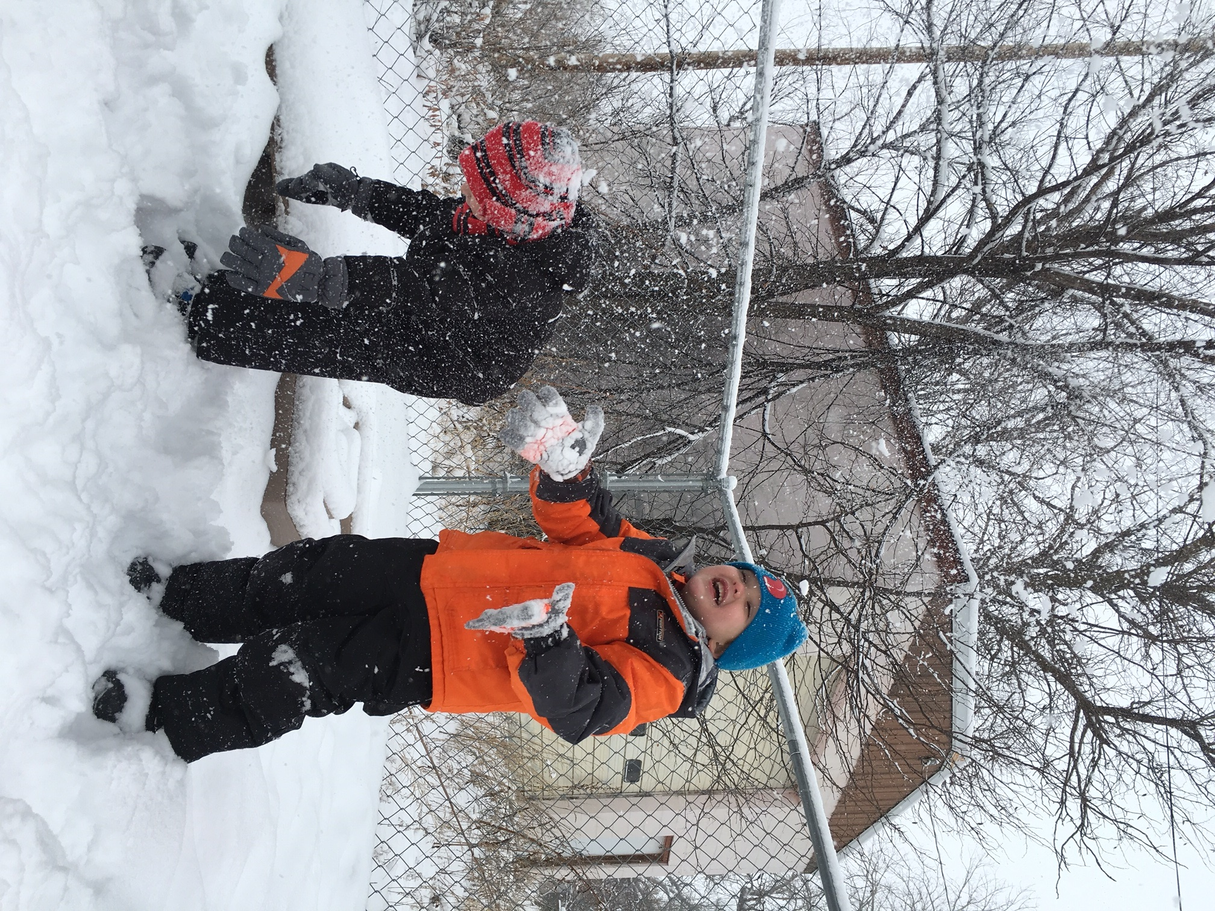
Belle Fourche Center students enjoyed the fresh snow on December 1st.
Pictured above: Spencer, Hudson, Ambrielle, and Ezra
Pictured below: Hudson and Ezra

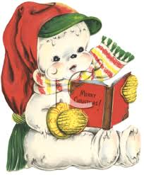
Your Parent Resource Library is a wealth of information!
We will be highlighting a book, DVD, or other resource from the Parent Library each newsletter. Check out a book or other resource and let us know if there is a book or resource we should add to the Parent Library! (Not all materials listed are at all sites.)

Wanda Dunn
Family Community Specialist

5 Top Tips to Encourage Reading
Let your child choose. Plan a field trip to the library and let your child choose books that interest them. A librarian can help steer them in the right direction, too. Keep books readily available at home, in the car, wherever your day takes you.
Read to your child. Establish a routine for reading. Whether before bed or at snack time, reading can fit into almost any part of your daily routine.
Read aloud together. It’s never too early to start reading to your little ones. For older kids, take turns reading each page of a favorite book.
Talk about what you are reading. Asking questions before, during and after the read helps your child make connections and increase reading comprehension skills.
Show your child that you enjoy reading. Be a reading model. Children often mimic parent behavior. Let your child see you enjoying reading and soon you may have an avid reader yourself.
From: Reading is Fundamental

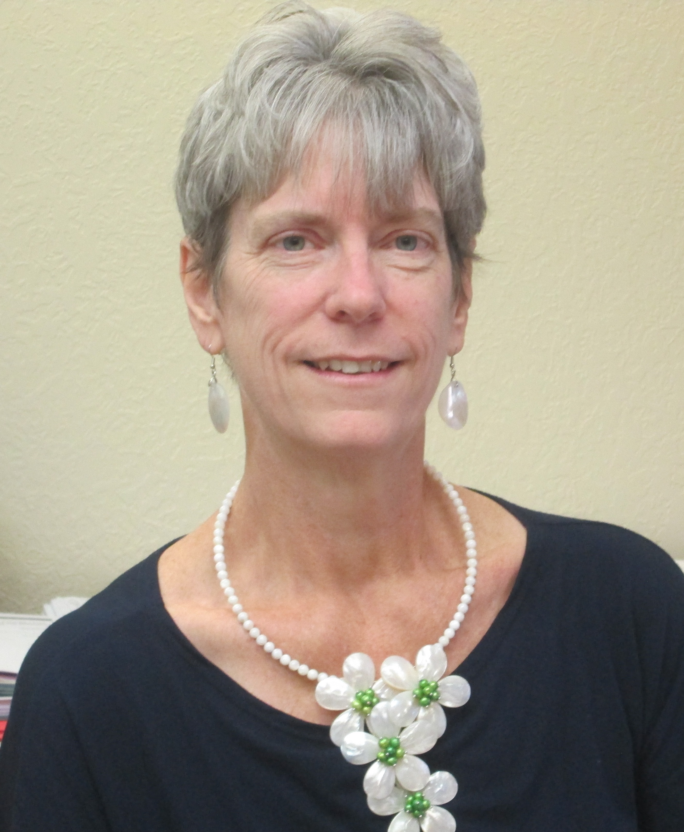


From the foremost authority on children's health--
a comprehensive guide to making peace at the table, feeding your baby, and creating healthy eating habits for the whole family
The American Academy of Pediatrics knows that the real challenge for parents isn't being aware of what to feed kids--it's getting children to actually eat those foods. From the preeminent organization in the field, the Guide to Your Child's Nutrition is a source of reassuring advice to help parents raise healthy children. Beyond simple guidelines describing the dietary needs of children from birth through adolescence, the Academy gives tips on:
¸ choosing what's best for your newborn
¸ introducing solid foods
¸ feeding toddlers and picky eaters
¸ reducing fat and salt for children of any age
¸ keeping adolescents eating well
¸ identifying allergies in children
The AAP Guide to Your Child's Nutrition uses a two-color format to make its information easy to use and quick to find. Sidebars offer low-fat snacks and menus, help for allergy sufferers, and a plethora of suggestions to make mealtimes easier and healthier for everyone

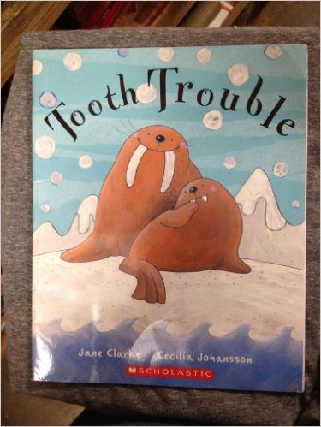
Written by: Jane Clarke and Cecilia Johansson
Wilbur’s tusk hurts, but he doesn’t want to go to the dentist – until a visit to Grandpa persuades him that it just might be a good thing…
Families are the heart of school readiness
When families involve their young children in daily learning by talking with them, playing with them, and reading to them from birth, children have:
- Higher literacy skills
- Better peer interactions
- Fewer behavior problems
- Greater motivation and persistence during learning activities

In other words, children whose families involve them in learning at home are more successful in school!

Head Start understands and values the key role families play in children’s school readiness. As a parent, grandparent, or other adult family member, there are many ways you can support your child to reach her greatest learning potential. Below are some steps to help your child learn.

Steps to School Readiness

- Find Out How Children Learn
What you do with and say to your child makes a big difference, so it is important to know how children learn.
- Babies begin to learn even before they are born! Find out what your baby learns in each month of his very first year.
- Each child develops at his own pace, but there are milestones that most children reach. If you know what developmental milestones to look for, you will know what changes and accomplishments to expect as your child grows.
- When children are healthy and safe, they are able to focus on learning and developing the skills they need to succeed in school. There are many ways that a child’s health affects school readiness.
- Help Your Child Learn
Your child is learning all the time. Simple, everyday activities and routines at home, like mealtime, are perfect chances to help them learn important school readiness skills, including social-emotional skills, language and literacy skills, thinking skill (math), and physical skills. They also help him learn how to learn.
- There are many ways you can help your child learn while having fun doing everyday activities at home and in your community
- When you read, sing, and talk with your child, you are helping her learn about language and the world around her.
- When you child has a healthy mouth, she’s able to learn and grow to her greatest potential.
- Partner with Head Start Staff to Measure and Follow Your Child’s Progress in Learning
You know your child best. You know what they can do well, what they’re learning to do, and what they can’t yet do. It is important for you to share this information with Head Start staff so you can work together to set goals for your child and measure her progress towards those goals. These resources cover how children’s progress is measure in Head Start and how families are involved in the process.
- Your child’s Head Start program screens children to see if they are reaching milestones according to their age. Developmental screening can also help you find out if your child needs additional help so he develops to his greatest ability.
- If your child has special needs, you can work with her school to develop an Individual Family Service Plan (IFSP) or Individual Education Plan (IEP) that best meets her particular needs. As a partner with the school, you can build the foundation for her education and future success.
- With your help, your child has the power to succeed in school! There are many ways to help, at home and in partnership with his teachers or home visitors.

- Get Involved with Your Child’s Head Start Program
Children whose families are actively involved in their education do better in school. There are many ways Head Start families can be involved. You can share your culture with the children, help teachers prepare for center or socials, and complete in kind. You can organize family events, help with center committee meetings, or become a member of Policy Council or Health Services Advisory Council.

Becoming an effective advocate for your children requires becoming involved in their education and their lives. Being involved in your children’s lives is what it takes to be a great and successful parent!

If you would like to volunteer, let your child’s home visitor or teacher know or call Wanda Dunn at 723-8837.

Submitted by:
Wanda Dunn, Family and Community Partnership Specialist
Article taken from:
(ECLKC) Early Childhood Learning and Knowledge Center

A Healthy Holiday Perspective!
As parents, we know how much work, time and stress goes into the holiday season. So many of us find ourselves overstressed during this time of year. It’s important to remember stress doesn’t come as part of the holiday season; we invite it year after year! Why? For many of us, we simply enjoy it!

The best prevention of holiday stress is to expect and accept it. Sometimes the easiest way to lower our stress is to accept this rather than fight it. I see this in my mind as swimming downstream instead of upstream. Just reminding ourselves that this is typical and part of the holiday season can help us considerably.

Other things to remember are to keep our expectations realistic. No family is perfect and no child is perfect. Children do not automatically behave better because it is a holiday. In fact, a lot of children are overwhelmed and can experience sensory overload during this time of year as schedules get much more hectic. For some children, gifts are beyond their developmental level and cause frustration. For others, they got what they asked for but it wasn’t as special as television promised. We push to make memories and try to take in every opportunity to enjoy the holiday season. Consider shortening visits with certain family members or eliminating situations that you know your child just can’t handle.

Slow down and pick one or two of your favorite traditions. Sometimes less truly means more. Remind yourself and others, the holiday season is for giving. Have your children make homemade gifts that come from the heart and stay within your budget. Remember there is no “perfect” present.
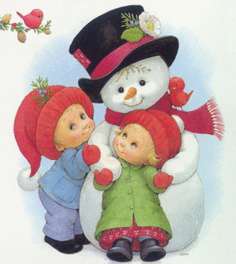

Make plans to relax this year and remember it is just one of the 365 days!

Rebecka Funk, Mental Health Specialist



Melissa Pickle
Program Services Director/Education-Disabilities Specialist

During the winter months it can be tempting to stay inside to avoid the cold weather. However, getting outside is important to maintain good mental health for both children and adults. Here are some fun activities to get you and your child outdoors:

- Coloring snow is a fun activity that will help your child learn about colors, develop fine motor skills in his or her fingers, and spur a sense of creativity. Simply put some water into some spray bottles along with some food coloring. Let your child spray designs into the snow. You can discuss the different colors you are using, have your child guess what happens when colors are mixed together, etc. Your child will also build muscle strength and coordination in his or her hands by having to squeeze the mechanism on the spray bottle to get the water out.
- Blowing bubbles when the temperature is less than 32 degrees is a wonderful way for your child to begin to learn science concepts as the bubbles will freeze on the wand. Blowing bubbles is also a great way for young children to build coordination in their mouths which helps with making speech sounds correctly.
- Instead of building sand castles, build snow castles! You can also use baking pans and cookie cutters to create snow molds in various shapes and sizes. This activity will inspire your child’s creativity and well as develop fine motor and gross motor skills.

Saying rhymes and doing finger plays with your child will help build your child’s language skills at any age. Here are some fun rhymes and finger plays to do with your child for this time of year.

Chubby Little Snowman
A chubby little snowman had a carrot nose.
(Point to nose)
Along came a bunny and what do you suppose? (Put 2 fingers up and “hop” them like a bunny)
That hungry little bunny, looking for his lunch
(Rub your belly)
At that snowman’s carrot nose,
(Use your hand to “chomp” like a mouth)
Nibble, nibble, CRUNCH!
(Clap-2 softer and 1 loud for “CRUNCH!”)

Five Little Snowmen
Five little snowmen on a winter’s day;
The first one said, “Wake up so we can play.”
The second one said, “Let’s stomp on the ground.”
The third one said, “Let’s roll around.”
The fourth one said,”Let’s run and run and run.”
The fifth one said, “I’m afraid I feel the sun.”
“Oh dear,” cried the snowmen, as they looked toward the sky.
And the five melting snowmen waved a fond goodbye.

Merry Snowflakes
Merry little snowflakes falling to the ground,
(Fingers flutter like falling snow)
They're landing on the treetops, covering our town.
(Fingers flutter)
They softly fall on noses
(Touch nose)
And make our hair look white.
(Touch hair)
They seem to call, 'Come out and play!'
(‘Come here' motion)
As they fall throughout the night.
(Repeat first action)

It is hard to believe that we are half-way through our Head Start year! With the last bunch of snow, it was a reminder to families and staff to be aware of winter safety, traveling and preparedness. It also provided an opportunity to incorporate winter themes of snow, snowmen, traditions, winter books, stories, and songs that pertained to winter fun into the center and home visiting learning environment. Many staff have enjoyed sharing cooking and crafting experiences with the families and students on home visits and at centers.

Below is a simple and inexpensive recipe that families can use with their children to make decorations, hand prints etc.:

1 c. corn starch
2 c. baking soda
- ½ c. cold water

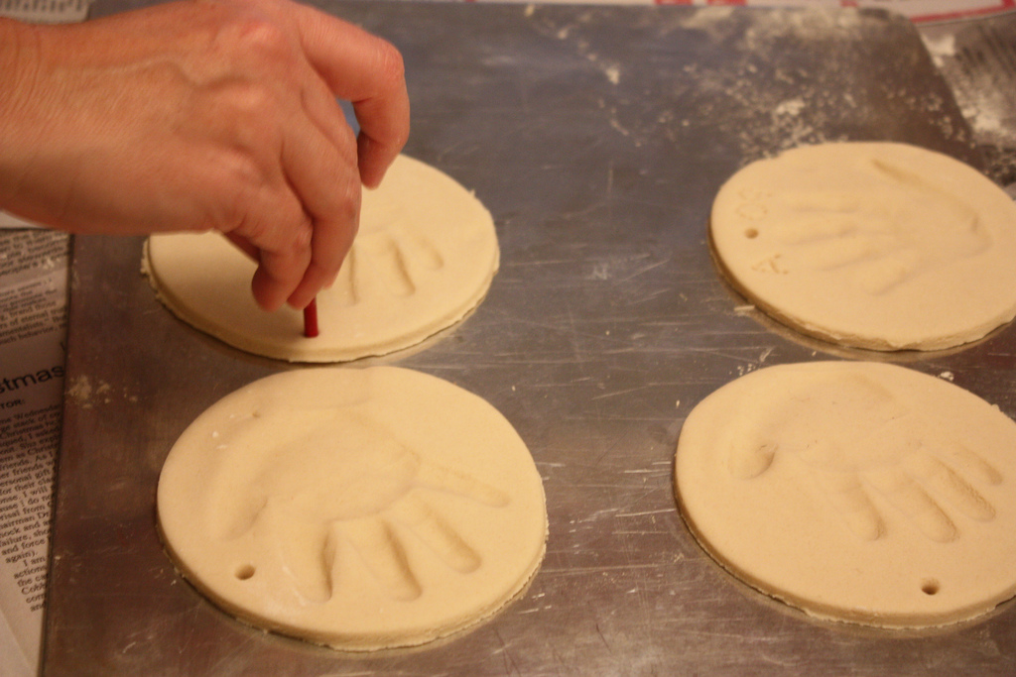
- Stir soda and cornstarch in medium saucepan
- Add water and stir until smooth
- Cook over medium heat and stir constantly until mixture looks like dry mashed potatoes
- Let cool until it is safe to handle
- Sprinkle work space with cornstarch and knead until smooth and easy to shape. (Use cookie cutters or create your own shape)
- Let dry overnight or in a 350* oven for 15 minutes.
- Paint when dry and hard.

Dough will keep in fridge for two weeks.
If making to hang up, make sure to use a small round object to make a hole for hanging prior to drying.

Wishing staff and families a safe and enjoyable Holiday season! See you in 2016!
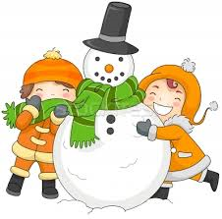
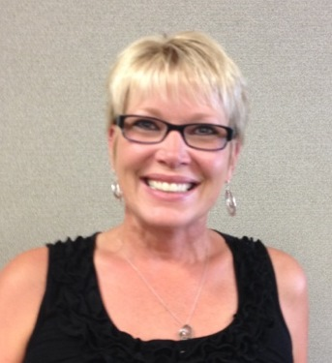

Ruth Adams
Area Services Manager
Lemmon, Bison and Harding County

Winter is here!! So let me share with you some more activities that you can do with your little ones on a cold and snowy day.

Snow Scape
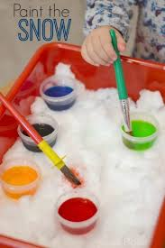
Materials:
- Clean snow 2. Tray 3. Towel 4. Food color

What to do: Collect some clean snow or make it by crushing ice cubes. Place a cup of snow on the tray and let your child explore the snow. You can use a few drops of food coloring to tint the snow. Add a few favorite toys and let your child explore! The towel is for clean up as the snow melts.

This activity addresses fine motor development, cognitive skills and for science the properties of snow.

Taste and Tell
This is for all those picky eaters out there, try this taste test game.
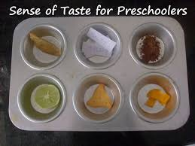
Materials:
- Variety of your child’s favorite foods and some new ones to try. Keep the foods similar in texture. Don’t use foods that you know your child hates.
- Bowls 3. Spoons 4. Blindfold

What to do: Place the food in individual bowls, and set the bowls in a row on the table. Give your child a spoon. Then point out all the foods and tell them you are going to play a game. Have them close their eyes or use the blindfold. Then fill the spoon with one of the foods have them taste it and guess which one they tried. Do this until they have tasted all the foods. Then you can talk about the different foods.

This activity addresses Language skills, Classification skills, exploration and risk taking.

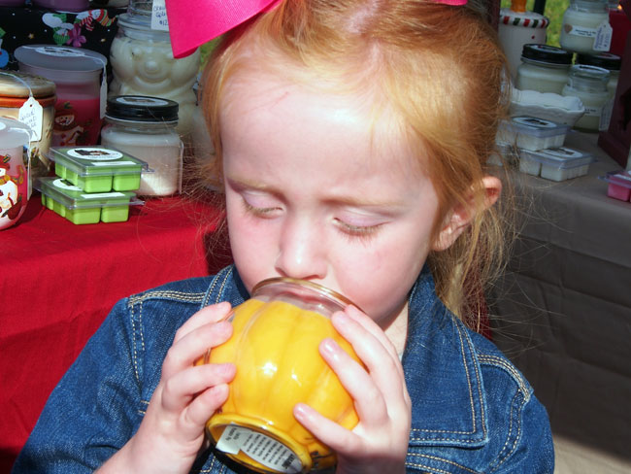
Candle Smells
This activity you can do at home or while at a store.

Have your child smell all the different aromas and see how many they can identify. Make a list of the different smells. Try to find other items that have the same smell. Cinnamon for example is found in foods, candles and candies.

This activity addresses Language skills, Classification skills and exploration.
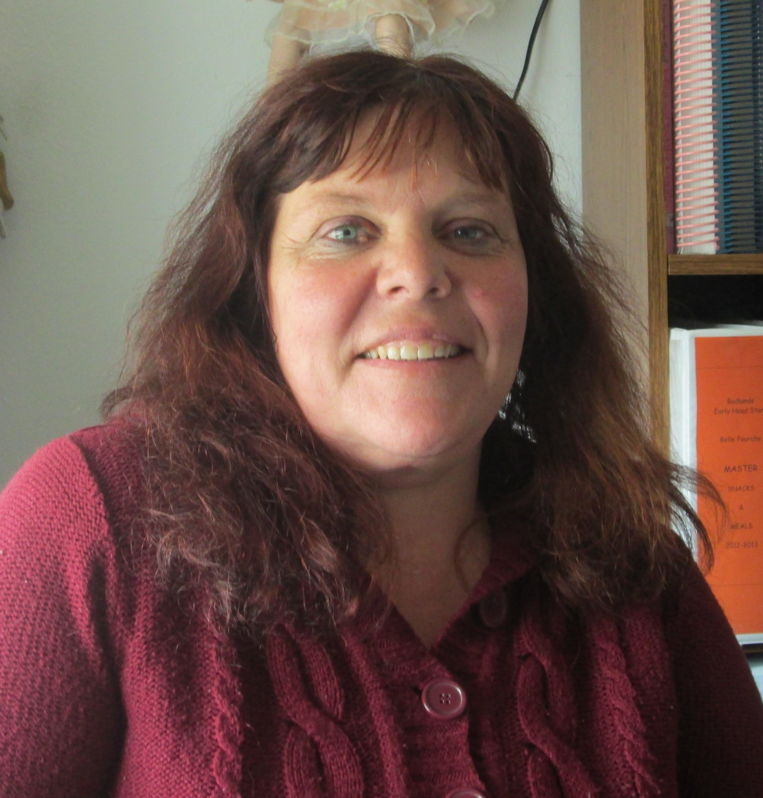

Have fun exploring!
Michele Kreuzer-Ranken ASM Butte County

